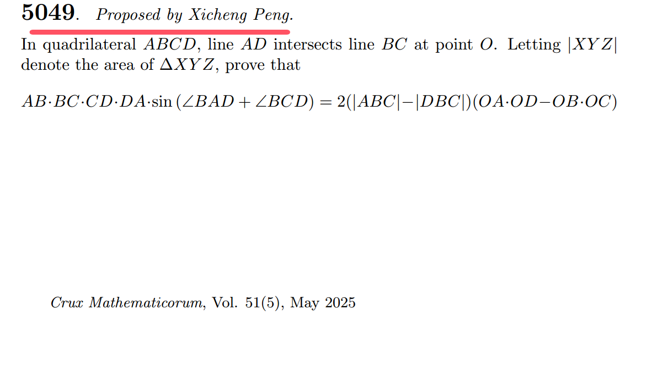

Dear Editor

I am writing to share a conclusion I have derived, which I believe is a significant and valuable result that would be a great fit for your journal.

This conclusion is an extension of the Power of a Point Theorem, where I have applied a quantitative treatment to the theorem. From this result, it can be concluded that . Moreover, the conclusion also addresses the case when the four points are not concyclic.

This is a very elegant conclusion. The equation contains rich geometric elements, involving line segment lengths, angles, areas, collinearity, and concyclicity. The left-hand side of the equation  is the product of the lengths of the sides of a quadrilateral multiplied by trigonometric functions, where the value of  determines whether the four points are concyclic. The right-hand side involves the difference between the areas of two triangles and the difference in the products of line segments, where the value of  indicates whether the line *AD* is parallel to or intersects with line *BC*. The intersection of lines *AD* and *BC* at point *O* is a known condition that has not been widely emphasized in previous research. In fact, this condition is essential for the validity of the Power of a Point Theorem, and it should be reflected in the expression of the conclusion.

This result is an original contribution by the author. I have found that in previous geometric studies, often only special cases are considered, such as when four points are concyclic, a certain conclusion holds. However, the question arises: how can this conclusion be extended when the four points are not concyclic? This is an important question that requires further thought. I have developed a mature methodology to address such problems and, if possible, I would like to submit a paper on this topic to your esteemed journal.

Thank you for your consideration.

Sincerely,  
Xicheng Peng

An Extension of Power of a Point Theorem- Problem Section Submission

Xicheng Peng pxc417@126.com

Faculty of Artificial Intelligence in Education, Central China Normal University, Wuhan 430079, China

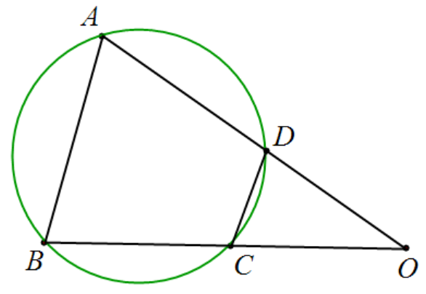

**In quadrilateral****, line  intersects line  at point . prove:**



**Proof:** The proof uses complex numbers. We set point  as the origin and line  as the real axis.

Since points ****,****, and ****are collinear, we have:，This implies: .







；



.